ICEngineSoft Test Report

Report Date : Sun, Dec 18, 2022 , Time : 12:57:13 PM
Organization : Organisation, Operator : Operator
Data File : 18-12 T30 D70.xlsx, Last Modified Date: Sun, Dec 18, 2022,
Config. File : Kirloskar TV1 Engine.xls

Engine Details :

ICEngine set up under test is Kirloskar TV1 having power 5.20 kW @ 1500 rpm which is 1 Cylinder, Four stroke , Constant Speed, Water Cooled, Diesel Engine, with Cylinder Bore 87.50(mm), Stroke Length 110.00(mm), Connecting Rod length 234.00(mm), Compression Ratio 17.50, Swept volume 661.45 (cc)

Combustion Parameters :

Specific Gas Const (kJ/kgK) : 1.00, Air Density (kg/m^3) : 1.17, Adiabatic Index : 1.41, Polytrophic Index : 1.12, Number Of Cycles : 10, Cylinder Pressure Referance : 6, Smoothing 2, TDC Reference :-1

Performance Parameters :

Orifice Diameter (mm) : 20.00, Orifice Coeff. Of Discharge : 0.60, Dynamometer Arm Legnth (mm) : 185, Fuel Pipe dia (mm) : 12.40, Ambient Temp. (Deg C) : 27, Pulses Per revolution : 360, Fuel Type : Diesel, Fuel Density (Kg/m^3) : 835, Calorific Value Of Fuel (kj/kg) : 43070

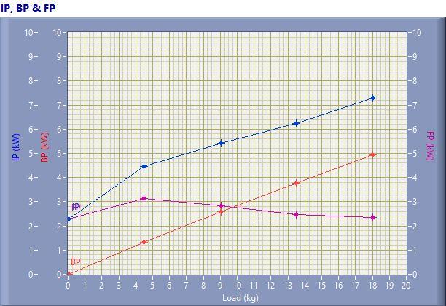

IP, BP & FP

Speed (rpm) | Load (kg) | IP (kW) | BP (kW) | FP (kW)
1558.00 | 0.03 | 2.29 | 0.01 | 2.28
1537.00 | 4.50 | 4.45 | 1.32 | 3.13
1503.00 | 9.06 | 5.43 | 2.59 | 2.84
1466.00 | 13.50 | 6.24 | 3.76 | 2.48
1442.00 | 18.03 | 7.30 | 4.94 | 2.36

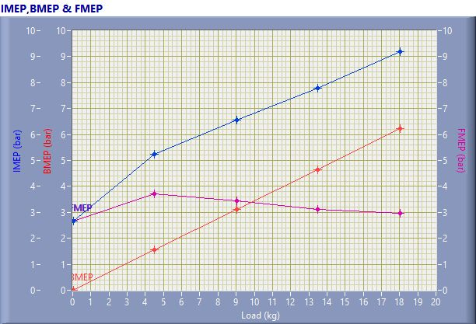

IMEP,BMEP & FMEP

Speed (rpm) | Load (kg) | IMEP (bar) | BMEP (bar) | FMEP (bar)
1558.00 | 0.03 | 2.67 | 0.01 | 2.66
1537.00 | 4.50 | 5.25 | 1.55 | 3.70
1503.00 | 9.06 | 6.56 | 3.12 | 3.43
1466.00 | 13.50 | 7.78 | 4.65 | 3.12
1442.00 | 18.03 | 9.18 | 6.22 | 2.96

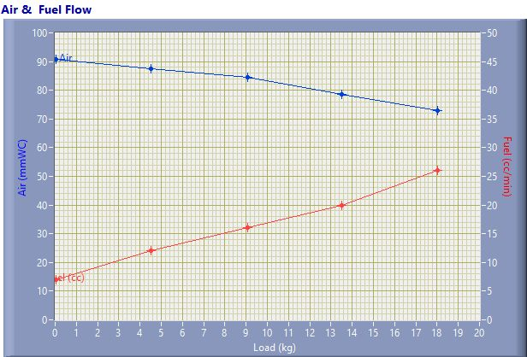

Air & Fuel Flow

Speed (rpm) | Load (kg) | Air (mmWC) | Fuel (cc/min)
1558.00 | 0.03 | 90.83 | 7.00
1537.00 | 4.50 | 87.61 | 12.00
1503.00 | 9.06 | 84.50 | 16.00
1466.00 | 13.50 | 78.53 | 20.00
1442.00 | 18.03 | 72.83 | 26.00

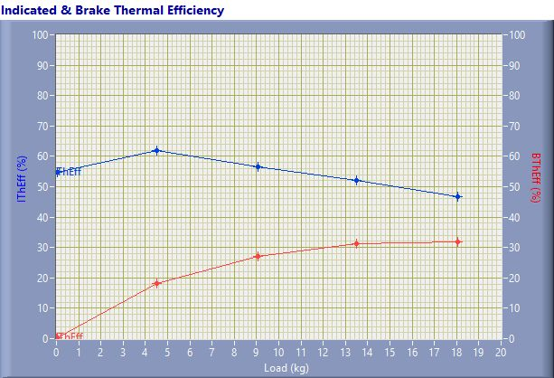

Indicated & Brake Thermal Efficiency

Speed (rpm) | Load (kg) | IThEff (%) | BThEff (%)
1558.00 | 0.03 | 54.68 | 0.23
1537.00 | 4.50 | 61.86 | 18.28
1503.00 | 9.06 | 56.64 | 26.98
1466.00 | 13.50 | 52.09 | 31.38
1442.00 | 18.03 | 46.83 | 31.71

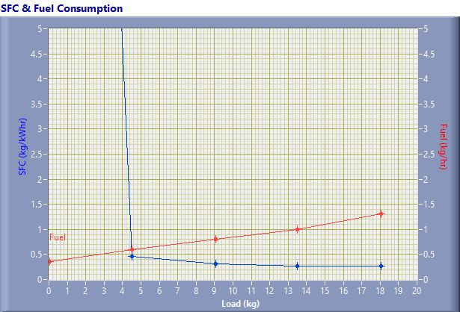

SFC & Fuel Consumption

Speed (rpm) | Load (kg) | SFC (kg/kWh) | Fuel (kg/h)
1558.00 | 0.03 | 37.01 | 0.35
1537.00 | 4.50 | 0.46 | 0.60
1503.00 | 9.06 | 0.31 | 0.80
1466.00 | 13.50 | 0.27 | 1.00
1442.00 | 18.03 | 0.26 | 1.30

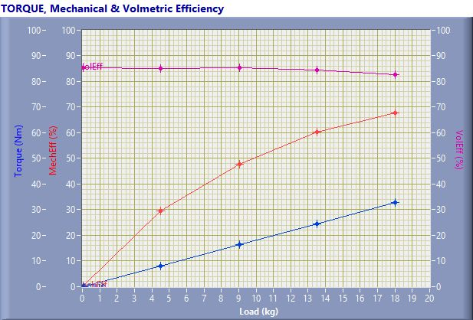

TORQUE, Mechanical & Volmertic Efficiency

Speed (rpm) | Load (Kg) | Torque (Nm) | Mech Eff. (%) | Vol Eff. (%)
1558.00 | 0.03 | 0.06 | 0.41 | 85.52
1537.00 | 4.50 | 8.17 | 29.56 | 85.14
1503.00 | 9.06 | 16.44 | 47.63 | 85.50
1466.00 | 13.50 | 24.50 | 60.24 | 84.51
1442.00 | 18.03 | 32.73 | 67.71 | 82.74

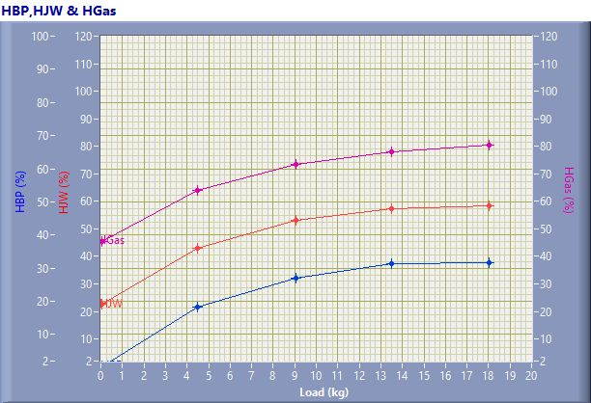

HBP,HJW & HGas

Speed (rpm) | Load (kg) | HBP (%) | HJW (%) | HGas (%) | HRad (%)
1558.00 | 0.03 | 0.23 | 22.42 | 22.81 | 54.55
1537.00 | 4.50 | 18.28 | 24.64 | 20.96 | 36.12
1503.00 | 9.06 | 26.98 | 26.11 | 20.40 | 26.52
1466.00 | 13.50 | 31.38 | 26.00 | 20.56 | 22.06
1442.00 | 18.03 | 31.71 | 26.82 | 21.90 | 19.57

Observation Data

Speed (rpm) | Load (kg) | Comp Ratio | T1 (deg C) | T2 (deg C) | T3 (deg C) | T4 (deg C) | T5 (deg C) | T6 (deg C)
1558 | 0.03 | 17.50 | 38.07 | 43.44 | 38.06 | 37.71 | 126.77 | 102.36
1537 | 4.50 | 17.50 | 38.12 | 48.24 | 38.12 | 39.68 | 185.70 | 140.55
1503 | 9.06 | 17.50 | 38.16 | 52.46 | 38.16 | 42.20 | 235.29 | 176.36
1466 | 13.50 | 17.50 | 38.20 | 56.01 | 38.21 | 45.11 | 297.10 | 219.08
1442 | 18.03 | 17.50 | 38.26 | 62.14 | 38.28 | 49.94 | 394.29 | 279.36

Observation Data

Air (mmWC) | Fuel (cc/min) | WaterFlow Engine (lph) | WaterFlow Cal (lph)
90.83 | 7.00 | 150 | 75
87.61 | 12.00 | 150 | 75
84.50 | 16.00 | 150 | 75
78.53 | 20.00 | 150 | 75
72.83 | 26.00 | 150 | 75

Result Data

Torque (Nm) | BP (kW) | FP (kW) | IP (kW) | BMEP (bar) | IMEP (bar) | BTHE (%) | ITHE (%) | Mech Eff. (%)
0.06 | 0.01 | 2.28 | 2.29 | 0.01 | 2.67 | 0.23 | 54.68 | 0.41
8.17 | 1.32 | 3.13 | 4.45 | 1.55 | 5.25 | 18.28 | 61.86 | 29.56
16.44 | 2.59 | 2.84 | 5.43 | 3.12 | 6.56 | 26.98 | 56.64 | 47.63
24.50 | 3.76 | 2.48 | 6.24 | 4.65 | 7.78 | 31.38 | 52.09 | 60.24
32.73 | 4.94 | 2.36 | 7.30 | 6.22 | 9.18 | 31.71 | 46.83 | 67.71

Result Data

Air Flow (kg/h) | Fuel Flow (kg/h) | SFC (kg/kWh) | Vol Eff. (%) | A/F Ratio | HBP (%) | HJW (%) | HGas (%) | HRad (%)
31.04 | 0.35 | 37.01 | 85.52 | 88.50 | 0.23 | 22.42 | 22.81 | 54.55
30.48 | 0.60 | 0.46 | 85.14 | 50.70 | 18.28 | 24.64 | 20.96 | 36.12
29.94 | 0.80 | 0.31 | 85.50 | 37.35 | 26.98 | 26.11 | 20.40 | 26.52
28.86 | 1.00 | 0.27 | 84.51 | 28.80 | 31.38 | 26.00 | 20.56 | 22.06
27.79 | 1.30 | 0.26 | 82.74 | 21.34 | 31.71 | 26.82 | 21.90 | 19.57

